YMCA Village People
Intro (2 bars of each chord, Kazoo comes in on Am):
[C] [Am] [F] [G]

[C] Young man, there’s no need to feel down, I said
[Am] Young man, pick yourself off the ground, I said
[F] Young man, cause you’re in a new town
There’s no [G] /need /to /be /un/ha/ppy.
[C] Young man, there’s a place you can go, I said
[Am] Young man, when you’re short on your dough, you can
[F] Stay there, and I’m sure you will find
Many [G] ways to have a good time. (STOP) -5 beats before chorus

CHORUS:
It’s fun to stay at the [C] YMCA. It’s fun to stay at the [Am] YMCA, They have [F] everything for you men to enjoy, You can [G] hang out with all the boys.
It’s fun to stay at the [C] YMCA. It’s fun to stay at the [Am] YMCA, You can [F] get yourself cleaned, you can have a good meal You can [G] do whatever you feel

[C] Young man, are you listening to me, I said
[Am] Young man, what to you want to be, I said
[F] Young man, you can make real your dreams, But you’ve
[G] /got /to /know /this /one /thing...
[C] No man does it all by himself, I said
[Am] Young man, put your pride on the shelf and just
[F] Go there, to the YMCA
I’m sure [G] they can help you today (STOP) -5 beats before chorus

CHORUS
[C] Young man, I was once in your shoes, I said
[Am] I was down and out with the blues, I felt
[F] No man cared if I were alive
I felt [G] /the /whole /world /was /so /tight
[C] That’s when someone came up to me and said,
[Am] ”Young man, take a walk up the street, there’s a
[F] Place there called the YMCA
They can [G] start you back on your way (STOP) -5 beats before chorus

CHORUS
It’s fun to stay at the [C] YMCA.
It’s fun to stay at the [Am] YMCA,
They have [F] everything for you men to enjoy
(slowing down) You can [G] hang out with all the boys [C]

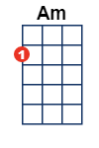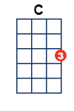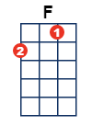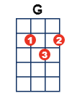/ – single strum

