#YinYanBand – Ukulele Starter Sheet
Tuning
No matter how good you are, if your ukulele is out of tune you will sound terrible! Tune your ukulele whenever you pick it up – new nylon strings stretch so you’ll have to tune it even more often at first!

Chords
We’re focusing on these 4 at first, these can be marked with coloured dots to get you started!
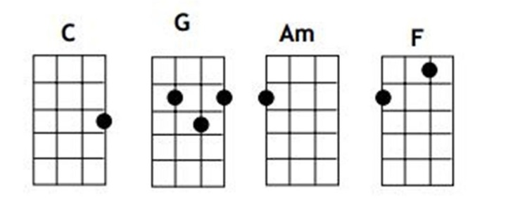 | If you have coloured dots:  C (green dot),  G (red dots),  Am (yellow dot)  F (blue dots)
Practice each chord on its own at first: Press your left hand fingertip(s) as shown (using the coloured dots as a guide), check you’re pressing in the right places by plucking each string individually with your right hand (at first you might not be pressing hard enough and/or might be accidentally touching another string).
Practice moving from chord to chord, SLOWLY at first! Then mix it up with different sequences – expect it to take time & practice, soon your transitions will get quicker and smoother!
Be patient and don’t expect miracles at first! With practice you’ll start to develop muscle memory and your fingertips will toughen up, making it much easier and more enjoyable!

Strumming
There are lots of ‘strumming patterns’ and different ones work better on different songs, but if you can master ‘Old Faithful’ you can play pretty much any song! It’ll take a while so be patient and start slooooooow!
Simple 4 count: Count to four out loud: “1 and 2 and 3 and 4 and 1 and 2 and 3 and 4 and …” Then strum downwards when you say a number, and strum upwards when you say ‘and’.
Now ‘Old Faithful’:
Only strum the strings as shown with the arrows – you’ll make loads of mistakes and it’ll probably sound terrible at first! Start slow and be patient with yourself, your brain is trying to process lots of information and new skills!  Be patient & keep practising ‘Down Down Up Up Down Up…’ over & over, eventually it’ll start to happen more naturally and you can start putting it together with the chords! | 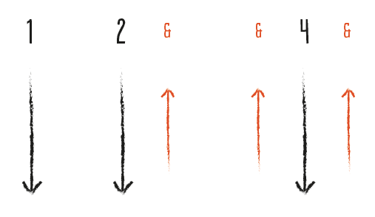

Top 10 Tips – Getting Started
- Expect to be sound terrible at first - although it can be really frustrating, that’s how EVERYBODY sounds at first!
- Know you’ll get better if you practice and be patient.
- Don’t give in to that little voice we all have saying you can’t do it because you sound terrible (see 1 & 2!), commit don’t quit!
- You’re learning a lot of smaller new skills (tuning, strumming, chords, rhythm, singing etc.) that make up one bigger skill - playing the ukulele! Work on the little skills individually and don’t try to put them together too soon, our brains don’t work that way!
- With focused practice, pretty quickly everything will start coming together and you’ll be playing the ukulele! You’ll get the satisfaction of having mastered a cool new skill, the thrill of being in a band and ALL the benefits of doing something fun & creative!
- If you find yourself getting annoyed or feel like you’ve hit a ‘wall’ – don’t worry, take a break and don’t give yourself a hard time, you’ll be surprised how much easier everything will be next time!
- Find ways & times to practice regularly – make it work for you
- Minimise distractions when you’re practising – you’ll learn more quickly!
- Explore different resources – there are countless YouTube tutorials, websites, clubs, books etc
- Connect with the rest of the band – we’re here to help eachother! Use #YinYanBand on social media

